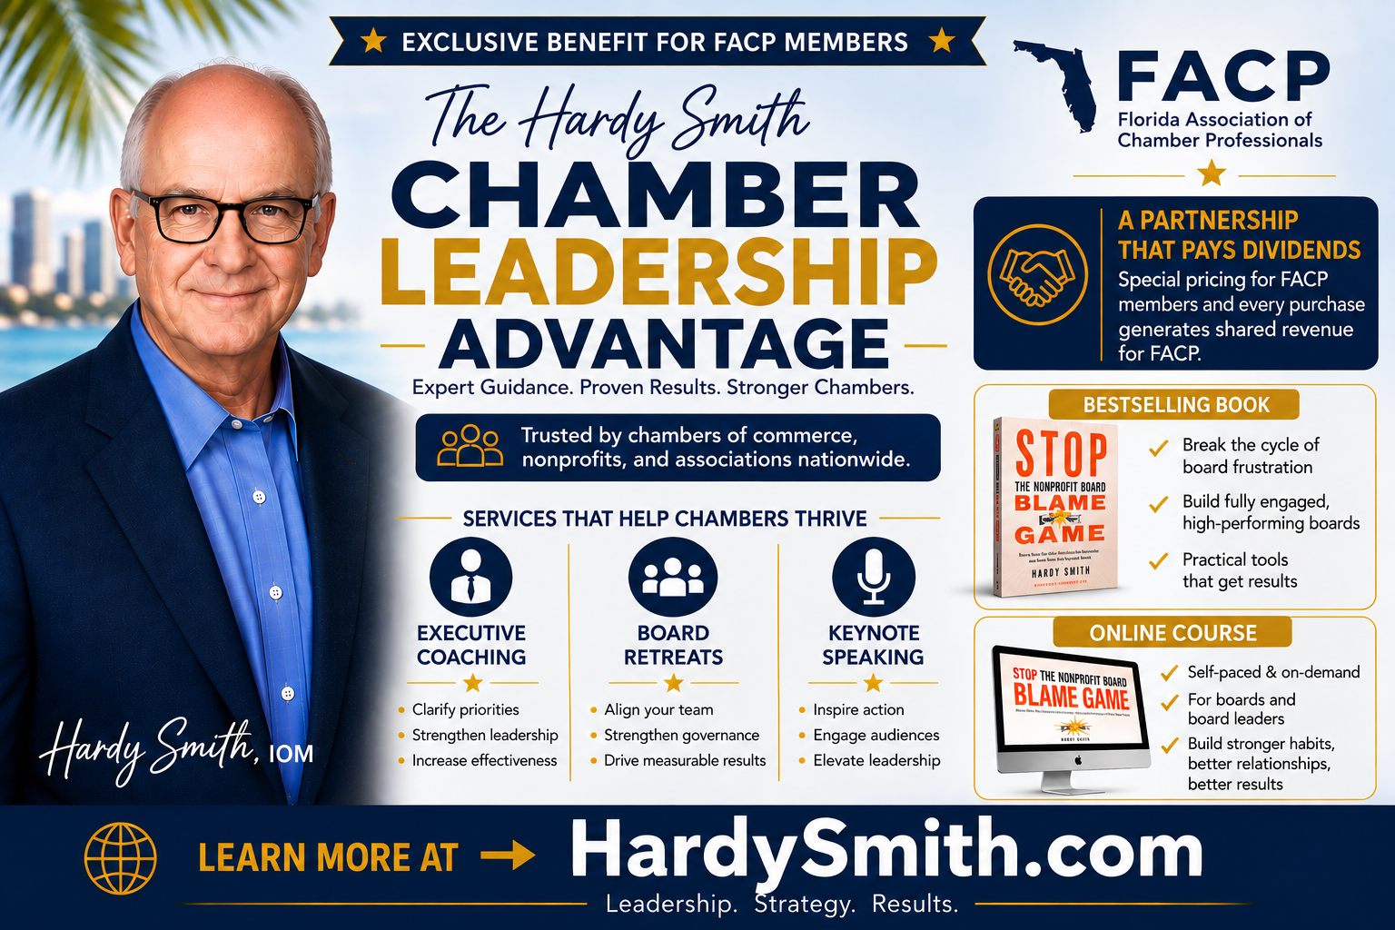
FACP and Hardy Smith Announce New Partnership to Benefit Florida Chambers
The Florida Association of Chamber Professionals (FACP) and Hardy Smith, IOM, have announced a new partnership designed to provide added value to FACP and its member chambers throughout Florida.
Through the partnership, FACP members will receive special pricing on services and resources included in Smith's FACP Chamber Bundle, while purchases by participating members will also provide a financial benefit to FACP.
“This partnership creates a win for both FACP and its members,” Smith said. “Chamber professionals will have access to discounted resources and services that can help strengthen their organizations, while their participation also supports FACP.”
Hardy Smith’s FACP Chamber Bundle includes:
- Stop The Nonprofit Board Blame Game book
- Stop The Nonprofit Board Blame Game Online Course
- Executive Coaching
- Board Retreats
- Keynote Speaking
- Workshops and Training Sessions
- Consulting Services
“I’m excited to further grow my relationship with FACP and its members and appreciate the opportunity to work with FACP CEO Tammy Bracewell to make this partnership possible,” Smith said. “I invite FACP members who want to learn more about the Chamber Bundle and available discounts to contact me at Hardy@HardySmith.com”
“We’re always looking for opportunities to provide additional value to our FACP members,” said Tammy Bracewell, CEO of the Florida Association of Chamber Professionals. “This partnership with Hardy gives our chamber professionals access to resources, expertise, and services designed to help strengthen their organizations and their leadership. We appreciate Hardy’s continued support of FACP and Florida’s chamber community.”
Hardy Smith, IOM, is the author of Stop The Nonprofit Board Blame Game and works with chambers of commerce, associations, and nonprofit organizations that want to benefit from positive, productive, and fully engaged boards.
Learn more about Hardy Smith at www.HardySmith.com

